**API Gateway**

**Amazon API Gateway** is a fully managed service that allows you to create, and monitor APIs (Application Programming Interfaces) at scale.

It acts as a **“front door”** for applications to access data, business logic, or functionality from your backend services like:

* AWS Lambda
* EC2 instances
* Other AWS services (e.g., DynamoDB, S3)

API Gateway Works

API Gateway as a traffic manager between your clients (mobile apps, web apps, IoT devices) and backend services.

**Workflow:**

1. **Client Request** → A mobile app, browser, or system makes an HTTP(S) request to the API Gateway endpoint.
2. **API Gateway Processing**:
   * Routes the request to the correct **backend service**.
   * Can transform requests/responses (e.g., JSON ↔ XML).
3. **Backend Integration** → API Gateway calls your backend service (Lambda, EC2, DynamoDB, etc.).
4. **Response** → The backend sends data back through API Gateway to the client.

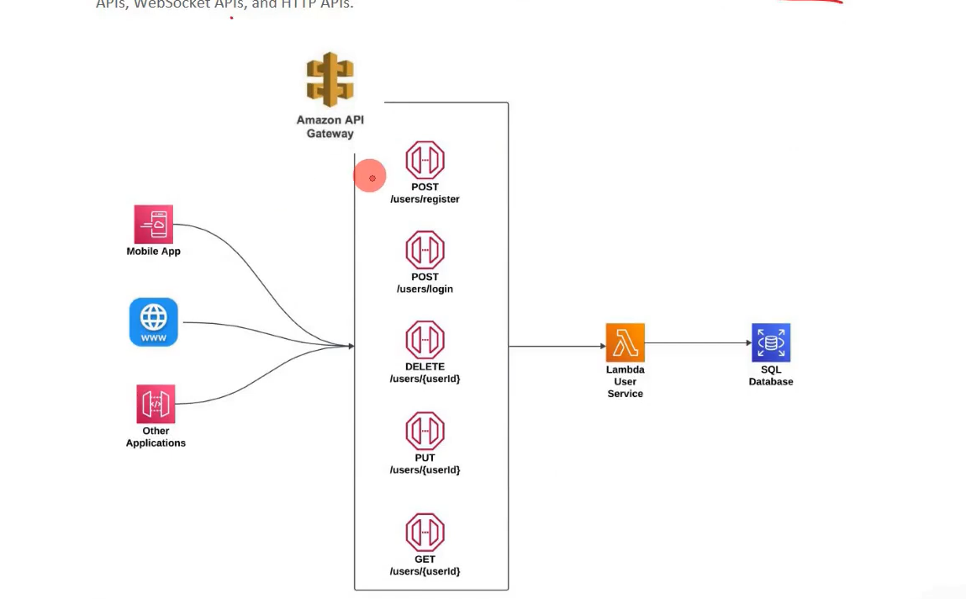

## **Why API Gateway is Used**

**Centralized API management** – manage multiple APIs in one place.

**Security** – control access via IAM, Cognito, API keys.

**Scalability** – handles millions of requests automatically.

**Performance** – caching responses reduces backend load.

**Cost-effective** – pay only for API calls and data transfer.

**Monitoring** – integrates with CloudWatch for logging and metrics.

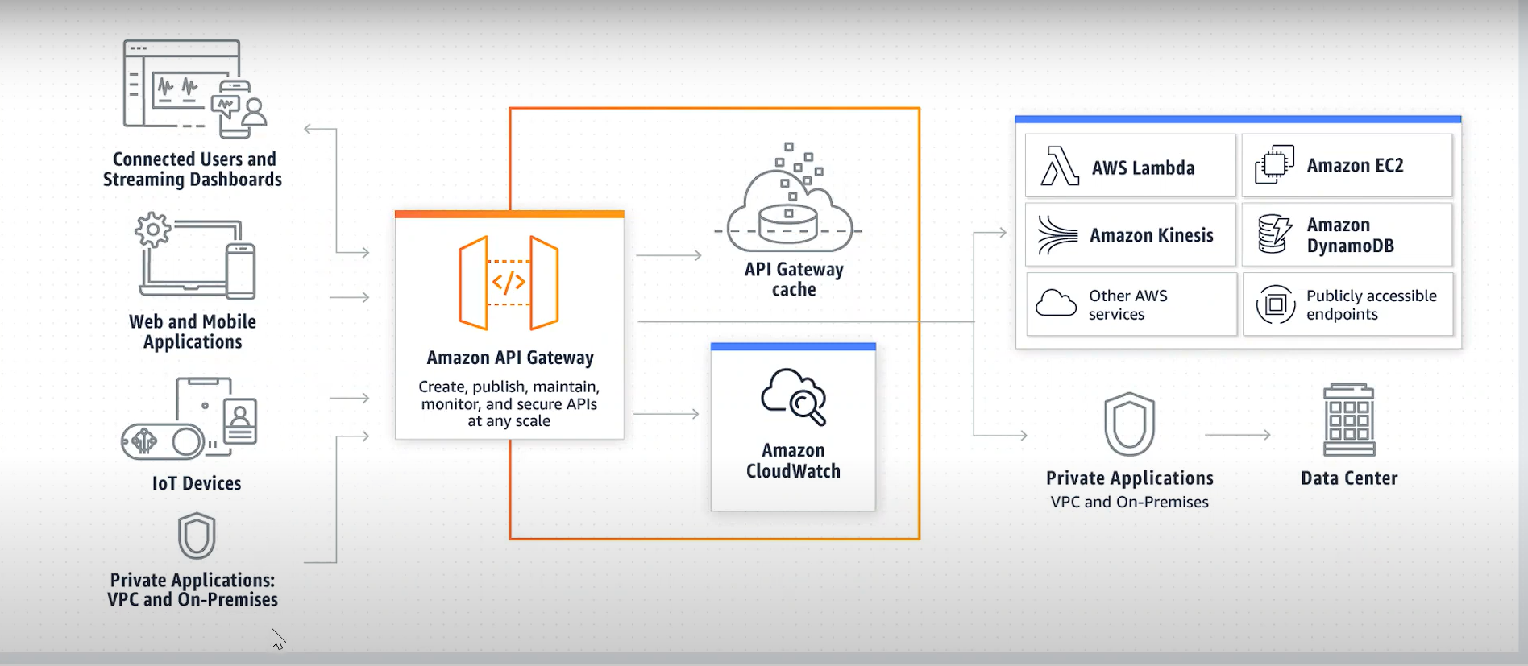

# Create a REST API with API Gateway and Lambda

**Step 1: Create a Lambda Function**

**Log in to the AWS Management Console.**

**Go to Lambda → Click Create function.**

**Choose Author from scratch:**

**Function name: MyLambdaFunction**

**Runtime: Python 3.x (or Node.js, Java — up to you).**

**In the code editor, paste a simple code**

**Click Deploy.**

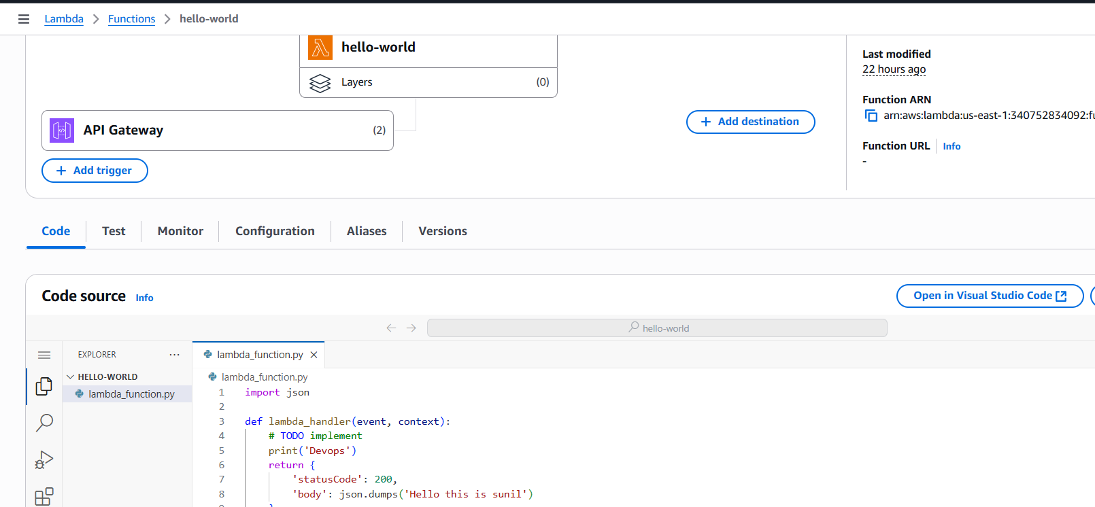

## Step 2: Create an API Gateway

1. **Go to API Gateway in AWS Console.**
2. **Click Create API → Select HTTP API (simpler than REST API).**

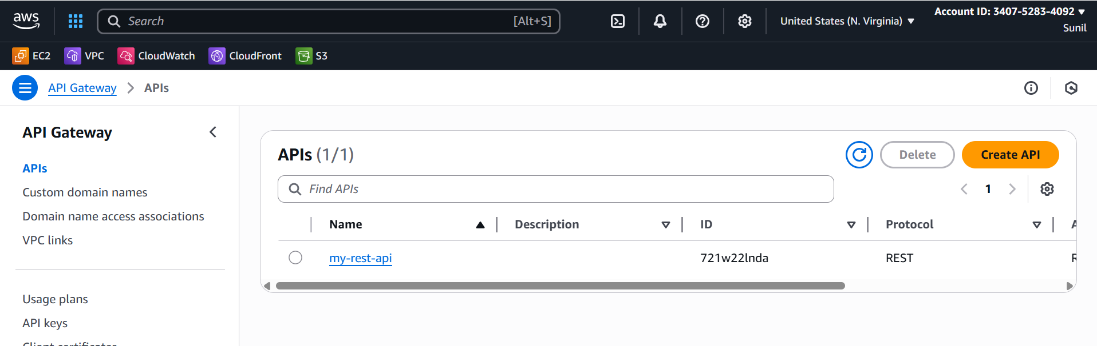

1. **In Integrations, select Lambda → choose your MyLambdaFunction.**
2. **Click Next → Configure routes:**
   * **Method: ANY or GET**
   * **Resource path: /Dev**
3. **Deploy the API.**

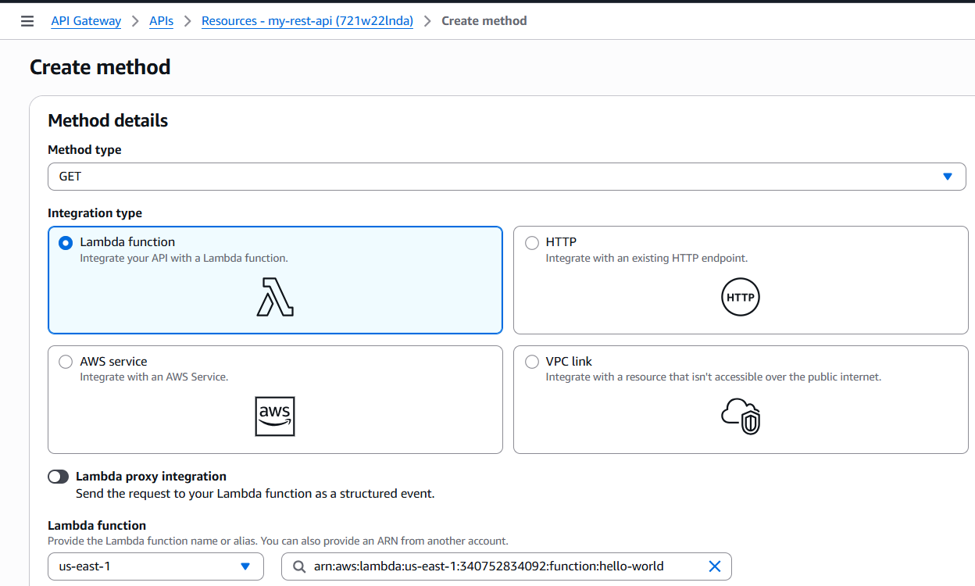

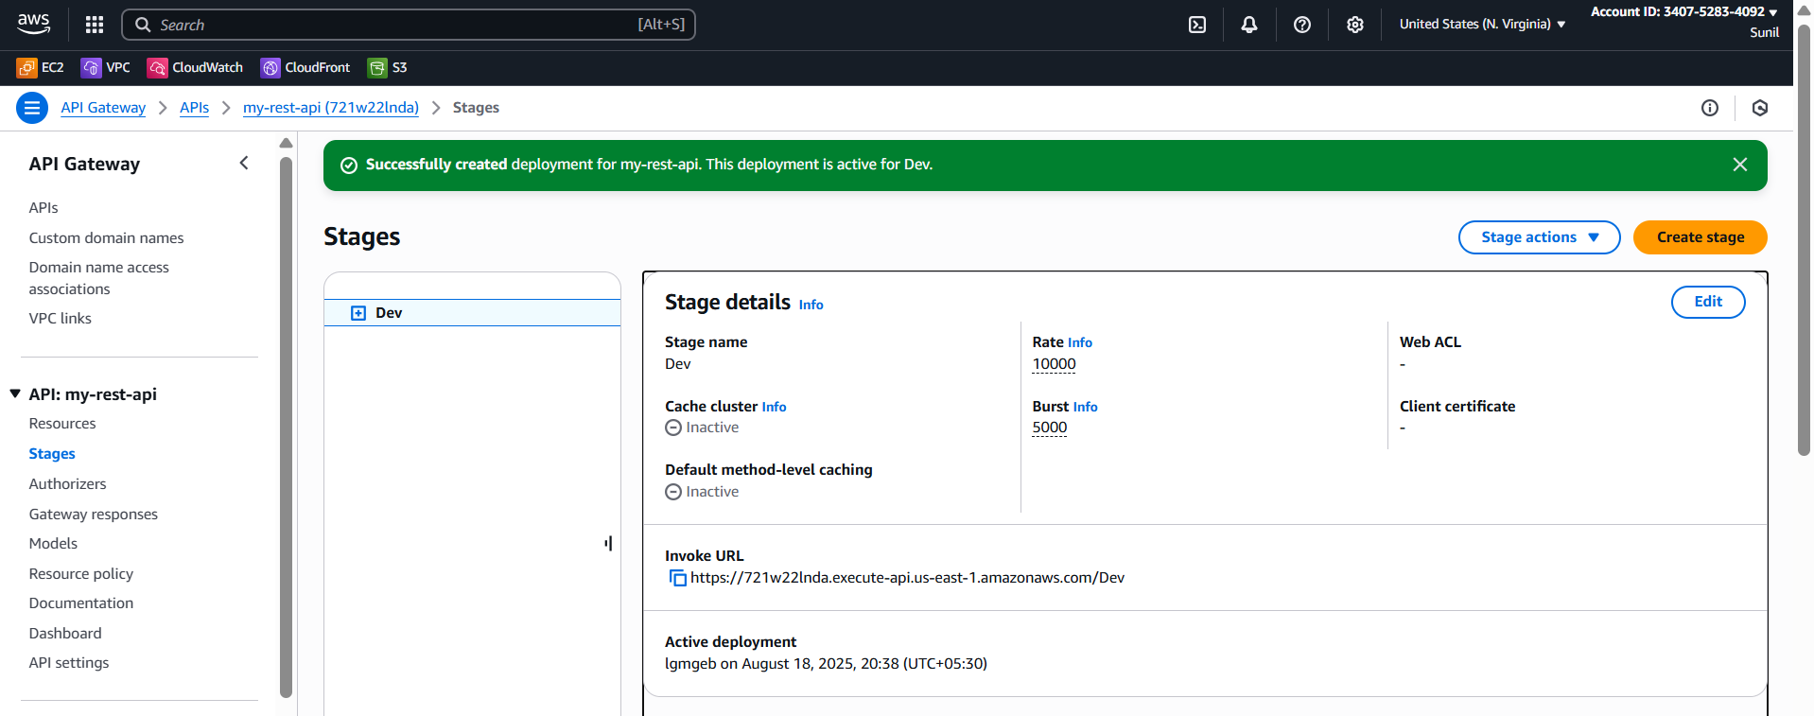

You’ll get an **Invoke URL** like:

<https://abcd1234.execute-api.us-east-1.amazonaws.com/test>

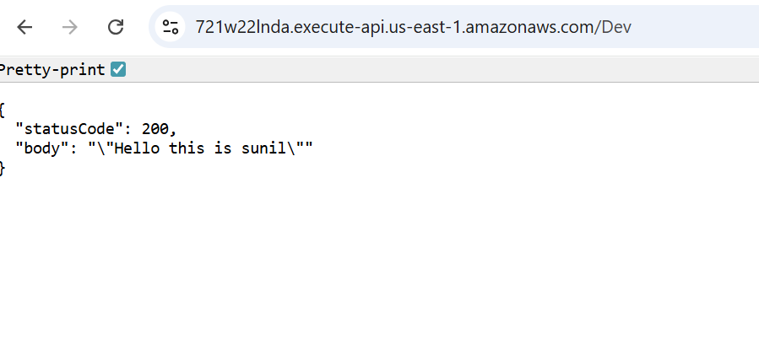

Test in Postman

Open **Postman**.

Create a **New Request**:

Method: GET (or POST if you want).

URL: Paste the **Invoke URL** from API Gateway,

